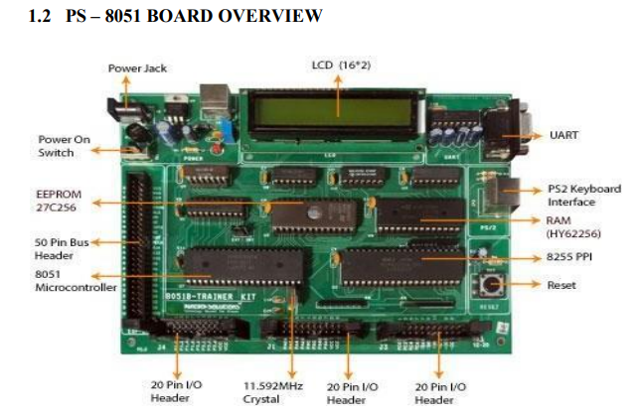

**8-BIT ADDITION**

**8-BIT SUBTRACTION**

**8-BIT MULTIPLICATION**

**8-BIT DIVISION**



